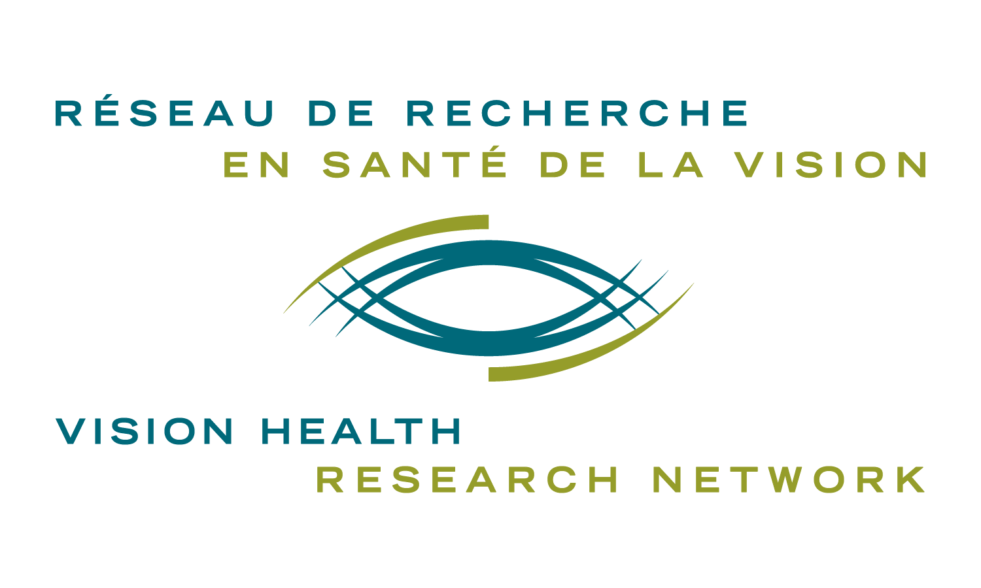
VISION NETWORK PUBLICATION AWARD

STUDENT PROGRAM
VISION HEALTH RESEARCH NETWORK (VHRN)

2019-2020 Competition

INSTRUCTIONS

Deadlines August 1st 2019*
February 1st 2020*
*Should these dates fall on a Friday or Saturday, the candidates will have until Sunday night to send their application.

Goal
This Vision Network Publication Award recognizes the excellence of vision health research performed by student members of the Network. The specific objectives of the program are to:
- promote careers in vision health research in Quebec;
- stimulate the participation of trainees in the planning and development of the Network’s activities;
- acknowledge their excellent work among the scientific community in Quebec and Canada.

Award
- An award of $250 is offered. If more than one author contributed equally to the work, the award is shared between these authors.
- The article and a short biography of the awardee will be featured on the VHRN web site.

Eligibility
Eligibility requirements specific to this competition include these criteria.
- Relevance to the vision, mission and research areas covered by the Network. Applications not corresponding to the Network’s mandate will not be reviewed.
- Must be first author of the research article. Manuscripts must have been published within the appropriate period for the competition (see Important Dates below).
- This award is open to all VHRN student members. You must be a student (undergraduate, graduate, or resident) or a postdoctoral fellow at any university, teaching hospital, research center or health-care organization in Quebec under the supervision of a VHRN member.
- Applications are accepted up until 13 months after the completion of the degree that was ongoing at the time at which the research was carried out. Post-doctoral fellows must have completed their training less than 13 months before the application deadline.
- Both Quebec and international students doing research in Quebec are eligible.
- Quebec students doing research abroad are not eligible.
- There is no requirement to be a FRQS or VHRN grantee to apply.
- Only one submission per applicant/per competition will be accepted.
- The awardee must submit their application to the Prix Relève étoile Jacques-Genest of the Fonds de recherche du Québec – Santé (FRQS)

Documents to submit
Submissions that meet the eligibility criteria (see Important Dates below) are welcome at any time during the year with evaluation taking place on a bi-annual basis. These documents are to be provided by the student:
- “Vision Network Publication Award” application form duly completed;
- copy of the published article in PDF format;
- picture of the candidate.

Review Process and Evaluation Criteria
The award is based on the excellence of research and its relevance to the Network’s mandate. Each submission will be evaluated and ranked according to their merit based on the following criteria:
- level of the student/trainee or stage of his/her career: quality of the research based on the experience of the applicant;
- specific contribution of the student or trainee: the individual’s specific contribution to conception and design of the study, acquisition of data and analysis and interpretation;
- quality of the publication: innovation and contribution to the field of research;
- impact of the publication: potential impact of the research to the target audience and beyond the specific field of study (does the research have the potential to stimulate additional research, to be translated into products, services, policies, educational material, practice documents?).

Important Dates
The evaluation committee meets twice a year to review applications received by the application deadline.

Vision Network Publication Award - Summer competition
- February 1st 2019 to August 31st 2019: article publication date
- August 1st 2019: deadline for submitting an application
- August 20 2019: winner(s) will be announced
- September 1st 2019: mandatory submission of the article(s) by the awardee to the provincial competition Relève étoile Jacques-Genest of the FRQS (FRQS web site)

Vision Network Publication Award - Winter competition
- August 1st 2019 to February 29 2020: article publication date
- February 1st 2020: deadline for submitting an application
- February 20 2020: winner(s) will be announced
- March 1st 2020: mandatory submission of the article(s) by the award recipient to the provincial competition Relève étoile Jacques-Genest of the FRQS (FRQS web site)

Funding Conditions
The awardee of the Vision Network Publication Award commits to submit the winning article to the provincial competition Relève étoile Jacques-Genest of the FRQS before the deadline (September 1st or March 1st).Thus, it is strongly recommended for all applicants to read carefully all rules and regulations for the Relève étoile Jacques-Genest competition while applying to the Vision Network Publication Award.
Important: The Vision Network Publication Award will only be awarded once a proof of submission to the Relève étoile Jacques-Genest competition is transmitted to us.

Number of prizes awarded: This number is dependent on the availability of funds.

Submit an electronic version of your application to: reseau.vision@ircm.qc.ca
For additional information, please contact:
Vision Health Research Network
514-987-5636
reseau.vision@ircm.qc.ca
http://visionnetwork.ca/

VISION NETWORK PUBLICATION AWARD

2019 – 2020 Competition

APPLICATION FORM

Deadlines: ☐ August 1st 2019* ☐ February 1st 2020*

*Should these dates fall on a Friday or Saturday, the candidates will have until Sunday night to send their application.

LAST NAME, first name:

Email address:

Mailing address:

Phone number:

Program, University, Faculty and Department:

Correspondence language (French / English):

Supervisor’s information

LAST NAME, First name:

Email address:

Publication’s title:

Paper’s complete reference (Pubmed format):

Journal’s full name:

Publication status:

Final Publication date:

Could this project have an impact on the understanding and / or treatment of AMD?
☐ yes ☐ no

Does this publication result from the use of a VHRN resource? ☐ yes ☐ no
If yes, specify
☐ Common infrastructures (specify which ones: _________________________)
☐ National and International Networking Program
☐ Other (please specify: ________________________________)

VISION NETWORK PUBLICATION AWARD

2019 – 2020 Competition

APPLICATION FORM

- Explain how your article is linked to the Network’s mandate. Give a summary of your article and explain the pertinence to the Network’s mandate (200 words maximum).

- Describe your personal contribution to the conception, acquisition and analysis of the study and data (200 words maximum).

- Describe the impact of your research. Explain the relevance of your research to the advancement of the vision health research field and beyond (200 words maximum).

- Write a short bibliography describing past training and research experience in French and English (250 words maximum).

