

STUDENT PROGRAM

GRADUATE STUDENT EXCELLENCE AWARD

2020-2021 Competition

VISION HEALTH RESEARCH NETWORK

INSTRUCTIONS

**Deadline: August 15, 2020\***

*\*Should this date falls on a Friday or Saturday, the candidates will have until Sunday night to send their application.*

**Goal**

These awards are intended to help and encourage graduate students (**MSc** and **PhD students**) in research in vision in order to better perform in competitions for awards from granting agencies (FRQ, CIHR, NSERC, SSHRC). Students will benefit from constructive comments of experienced evaluators that will allow them to consolidate their application and increase their chances of success in these competitions.

**Eligibility**

To be eligible for the VHRN “*Excellence Award*” competition:

* The candidate must be enrolled full-time in a Master’s or PhD program on or before **September 30, 2020**, in a master's or doctoral program under the supervision of a VHRN researcher member.
* The candidate’s research project must focus on vision health.
* It is the responsibility of the student to ensure his or her eligibility to the competition he or she will apply to.
* Only one Graduate Student Excellence scholarship can be awarded to a student during his or her studies (all levels included).

**Amount and number of awards**

The amount of an “*Excellence award*” will be **$ 2,500,** non-renewable and, the number of awards depends on availability of funds.

**Mandatory conditions following the grant**

The **recipients** undertake to **submit** his or her **scholarship application** to the FRQ (FRQS, FRQNT or FRQSC) in the current year (fall of the same year). They must provide the **acknowledgement receipt of their application** as well as **proof of registration** (if not present in the initial submission) in the following week to the VHRN. In the rare event that a candidate would not be eligible for a FRQ Master’s or a PhD training award, but would be eligible to a CIHR, NSERC or SSHRC competition, the candidate undertake to submit his or her scholarship application to one of this three organisms. Please visit the websites of the eligible organisms for their respective deadlines (see list below).

**Evaluation criteria**

The application will be assessed on the quality of the candidate’s record and his/her chances of success in the scholarship competition to which he/her will apply to. The evaluation grid of the chosen competition will be the one used by the VHRN Scientific Committee.

**Commitment**

Any recipient of a VHRN *“Excellence Award*” agrees to:

* Acknowledge the support of the VHRN in each presentation (oral or poster) and publication resulting from the project for which he was awarded the scholarship: By using the one of the following wordings, according to the publication language and to the research project topic:
  + « Le Réseau de recherche en santé de la vision » or « The Vision Health Research Network » if the project is not related to AMD;
  + « La Fondation Antoine Turmel et le Réseau de recherche en santé de la vision » or « The *Fondation Antoine-Turmel* and The Vision Health Research Network » if it’s a project related to AMD;
* Present the results of the research project at the VHRN Annual Meeting;
* Declare to the Network any additional awards received during the period funded by the Network;
* Respond to the requests for follow-up sent by the VHRN after the completion of the Master’s or PhD Degree in order to evaluate the efficiency of this program.

**Timelines**

* Deadline to submit application: **August 15\***
* Review and evaluation: **September 15**
* Notification of results and comments: **September 17**

*This date was chosen to allow the Scientific Committee to evaluate applications early enough that students can benefit from these assessments and use them to improve their scholarship application to major funding agencies. In the event that the deadline is on a Friday or a Saturday, the candidate will have until Sunday night to submit his or her application.

**How to apply**

The applicant must go to the link "[***GRADUATE STUDENT EXCELLENCE AWARD /*** *Prix**d’excellen*ce **electronic form**](https://app.kognitions.com/projform/1575903746159x642692332348042000?c=1591127978502x798387188167082000)”, complete the form and attach the appropriate documents:

* Full Application, following this order (**only one** **combined PDF Document** – including supervisor’s parts)

1. Additional **questions (Section 1)**
2. Fully completed copyof the **application form** for the Master’s or Doctoral Scholarship, as required by the granting agency to which the application is submitted (FRQS, FRQNT, FRQSC, CIHR, NSERC or SSHC). Please contact or visit the agency’s website for the forms, deadlines and more details:

* FRQS: <http://www.frqs.gouv.qc.ca/>
* FRQNT: <http://www.frqnt.gouv.qc.ca/>
* FRQSC: <http://www.frqsc.gouv.qc.ca>/
* CIHR: <http://www.cihr-irsc.gc.ca/>
* NSERC: <http://www.nserc-crsng.gc.ca/>
* SSHRC: <http://www.sshrc-crsh.gc.ca/>

**AND** these 4 sectionsif you are not applying for FRQS (sections included in the FRQS form)

**2a. Project Description** (**Section 2**)

**2b. Skills ans experience** (**Section 3**)

**2c. Training environment** (**Section 4**)

**2d. Layman abstract** (**Section 5**)

1. [**Canadian Common CV**](https://ccv-cvc.ca/) in FRQS format including [**detailed contributions**](http://www.frqs.gouv.qc.ca/documents/11314/710199/Directives+pour+le+fichier+joint+au+CV/808ab760-f35b-41ef-8bd1-8eaaa85c68e8)
2. **Completed transcripts** from all university degrees completed or in progress
3. **Scholarships, awards** and **distinctions notice**
4. Acknowledgement of **receipt of submitted articles**
5. Calculation of the **number of training program sessions** ([Calcul du **nombre de sessions**](http://www.frqs.gouv.qc.ca/documents/11314/6220302/Calcul_nombre_sessions_20_21_vf.docx/aed53194-a1c9-4121-97b6-b1382d42aa11) – French version only)
6. **Proof of residency** (valid RAMQ, Canadian citizenship or other official document)
7. **Proof of registration** at a Quebec University (if already available at the time of submission). Otherwise this proof will be required if you are a recipient of this award.

**SUPERVISOR’S PART**

1. [**FRQS’s electronic form**](https://frqnet.frq.gouv.qc.ca/researchPortal/faces/jsp/login/login.xhtml?lang=FR&site=null)completed by the **supervisor**

**OR** these 2 sectionsif you are not applying for FRQS(sections included in the FRQS form)

**10a. Integration Research Program** (**Section 6)**

**10b. Source of funding** (**Section 7**)

1. [**Canadian Common CV**](https://ccv-cvc.ca/) in FRQS format including [**detailed contributions**](http://www.frqs.gouv.qc.ca/documents/11314/710199/Directives+pour+le+fichier+joint+au+CV/808ab760-f35b-41ef-8bd1-8eaaa85c68e8) of your supervisor

* Students status update from the laboratory (**EXCEL Document**)

The candidate must ask his supervisor to provide him with this document. This is an **update of the monitoring of students in his laboratory who are or have been funded in the past by the VHRN** (studies in vision, success in scholarship competitions, graduation, and position held). Upon request, the VHRN will provide a copy of this document, which the researcher will only have to update. The candidate must attach this document to the form.

Incomplete and / or non-compliant applications will be rejected.



**For additional information, please contact:**Vision Health Research Network (visionnetwork.ca)

[reseau.vision@ircm.qc.ca](mailto:reseau.vision@ircm.qc.ca)

514-987-5636

GRADUATE STUDENT EXCELLENCE AWARD

2020-2021 Competition

ELECTRONIC FORM

(for information only)

THESE INFORMATIONS WILL HELP YOU COMPLETE THE ELECTRONIC FORM.

|  |  |  |  |
| --- | --- | --- | --- |
| **NOTE :** | *At any moment, you can save and continue filling out the form later. A link will be sent to you via your email.* | | Continue later |
|  |  | |  |
|  | Previous | *At any moment, you can go back to the previous step.* | |

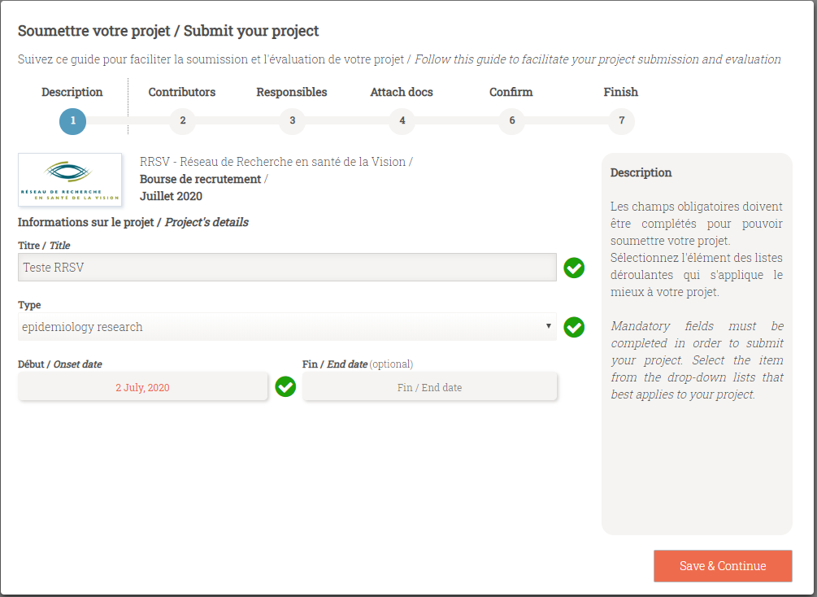

## Step 1 - Description

## Informations sur le projet / *Project’s details*

## Titre / *Title*: *MSc / PhD project’s title to which this application is related*

## Type: *choose from the drop-down list the type of research – discovery research, translational, clinical, etc.*

## Début / *Onse*t: *date scheduled to start or when you have started this diploma*

## Fin / *End date* (*optional*): *end date of this diploma if known. If the date is unknown, write nothing*

|  |  |
| --- | --- |
|  | Save & Continue |

## Step 2 - Contributors

## Information sur la personne / *Person’s information*

## Courriel / *Email*: *applicant’s email address*

## Prénom / *First Name*, Nom / *Last Name:* *complete the fields*

## *Rôle* / *Role*: *choose the option: « Student / Trainee »*

## Expérience / *Experience*: *choose from the drop-down the degree which this application is related: Master, Doctorate, Other*

## Discipline: *choose from the drop-down list the area of research by starting to write*

## Secteur / *Sector*: *will be displayed automatically according to the chosen discipline, do not write anything*

## Affiliation principale / *Principal affiliation*: *identify the place where you will perform your research – École d’optométrie, Research Center or Institute X, University of X, etc.*

|  |  |
| --- | --- |
|  | Save contributor |

|  |  |
| --- | --- |
| MANDATORY:*To add your supervisor, click on* New contributor .*Complete the fields.* *Rôle* / *Role*: *choose the option: « Director »* |  |
| Save contributor |

|  |  |
| --- | --- |
| OPTIONAL:*If you have a co-supervisor, click again* New contributor *and complete the fields.**Rôle* / *Role*: *choose the option: « co-Director »* |  |
| Save contributor |

|  |  |
| --- | --- |
| *When you have finished adding all the contributors:* | Save & Continue |

**Step 3 – Responsibles**

**Responsables du projet** / ***Project responsibles***

|  |  |
| --- | --- |
| *The project responsible is the applicant i.e. student.* | Save & Continue |

**Step 4 – Attach docs**

**Téléverser les documents requis (si applicable)** / ***Upload all required documents (if applicable)***

|  |
| --- |
| *Click to upload your documents one at the time and click on* UPLOAD .*(only one combined PDF document + Excel document).* |

|  |  |
| --- | --- |
| *When both documents are attached:* | Save & Continue |

**Step 5 – Confirm**

**Résumé de l’information à soumettre** / ***Resume of the information to submit***

|  |  |
| --- | --- |
|  | Save & Continue |

**Step 6 – Finish**

**Soumission préliminaire** / ***Pre-submission***

|  |  |
| --- | --- |
| *The applicant is the person in charge of the final submission.* | Envoyer courriel / Send email |

|  |
| --- |
| End of the electronic form*You will receive an email for the final submission.* Y*ou will have the opportunity to modify* ( Modifier / Modify ) *and review your application* (Visualiser le rapport / See report ) *before submitting.* |

|  |
| --- |
| *Following clicking on* SOUMETTRE / SUBMIT , *a submission confirmation window will appear.* *Confirm the final submission.* |

## ˃ Your application has now been submitted to the VHRN. ˂

**Applicant** (First name LAST NAME)**: ___________________________________**

SECTION 1 : ADDITIONAL QUESTIONS

1. Indicate your study program: ___________________________________________________
2. Could this project have an impact on the understanding and / or treatment of AMD?  yes  no
3. Does this project result from the use of a VHRN resource?  yes  no

If yes, specify.

Common Infrastructures (specify which ones: ______________________________________)

National and International Networking Program

Other (please, specify: ___________________________________________)

**Applicant** (First name LAST NAME)**: ___________________________________**

SECTION 2  : PROJECT DESCRIPTION (2 pages maximum)

Clearly describe your research project, respecting the following sections: **a)** research issues and hypotheses, **b)** research objectives, **c)** methods and analyzes, **d)** the feasibility, **e)** contributions to the advancement of knowledge, and **f)** a maximum of 6 bibliographical references.

**Applicant** (First name LAST NAME)**: ___________________________________**

SECTION 3  : SKILLS AND EXPERIENCE (1 page maximum)

Describe your participation in research projects and research training placements during your previous studies. Identify the directors of project and internship; indicate the start and end date of the activity. Please distinguish the mandatory training courses in research integrated into the university curriculum of the study program (Ex: Coop program), internships optional or followed on your own initiative (volunteers). Please also clearly define the added value of these internships in relation to your study program and the research project submitted.

**Applicant** (First name LAST NAME)**: ___________________________________**

SECTION 4  : TRAINING ENVIRONMENT (1 page maximum)

Justify your choice of training location and indicate the link between the training already acquired and that proposed in this request (in collaboration with the director of research). Please define the relevance of the project in relation to the training environment where the research will be carried out. If you are in co-direction, also describe the contribution of this aspect to the project.

**Applicant** (First name LAST NAME)**: ___________________________________**

SECTION 5 : LAYMAN ABSTRACT (300 words maximum for each language)

**Summary intended for the general public**. Brief description of your research program or project (**FRENCH** and **ENGLISH**).

FRENCH

ENGLISH

**Applicant** (First name LAST NAME)**: ___________________________________**

SECTION 6 - supervisor : INTEGRATION RESEARCH PROGRAM (500 words maximum)

Please explain how the applicant's research project fits into your overall research program. Please clearly define the role of the student in the laboratory, as well as the link between the relevance of the research project and the research environment. Please contextualize the integration of the research project and of the candidate into your research program according to your research status (early career researcher, senior researcher).

**Applicant** (First name LAST NAME)**: ___________________________________**

SECTION 7 - supervisor : SOURCE OF FUNDING

Identify the source of funding that will be used to fund the resources required to carry out the applicant's research project (e.g.materials and supplies, data collection, etc.).

**Funding Source:**

If it's a grant, please specify the type.

**Type of grant**:

**Annual amount of the grant:**

**Term of the grant:**

**From:** DAY-MONTH-YEAR

**To:** DAY-MONTH-YEAR