STUDENT PROGRAM
SCIENTIFIC PRESENTATION and TRAINING AWARD
2020-2021 Competition

VISION HEALTH RESEARCH NETWORK

INSTRUCTIONS

Deadlines: June 1st 2020* - cancelled
September 1st 2020*
December 1st 2020*
March 1st 2021*
*Should these dates fall on a Friday or Saturday, the candidates will have until Sunday night to send their application.

Objectives
The purpose of this initiative is to provide financial support to graduate student and postdoctoral fellows of the Vision Health Research Network (VHRN) for:
- Presentation (oral or poster) of research results at a national or international scientific dissemination activity (conference, symposium, workshop, scientific meetings)
- Training opportunities (short-term internship, visit a laboratory to develop / continue collaboration, training on cutting-edge equipment, participation to specialized course, etc.)

The specific objectives of the program are to:
- Promote networking and collaborations
- Facilitate participation of VHRN trainees to national and international meetings
- Reward excellence in vision health research by VHRN trainees
- Help trainees acquire unique expertise essential to increase research capacity

Eligibility
The eligibility criteria for this program are:

Relevance of the project to the mission and health research areas of the VHRN vision. Applications that do not meet the mandate of the VHRN will not be evaluated

This program is open to all student members of the Vision Network, including international trainees. You must be a student (MSc, PhD, medicine), postdoctoral fellow or resident at an university in Quebec, an university hospital, a research institute/center or another health organization under the supervision of a member of the VHRN

The event for which you are requesting support must take place no more than 3 months after the deadline date of application to the VHRN

Applications can be received throughout the year

Only one (1) application per candidate will be accepted per competition.

Amount and number of awards
- Funding of up to $ 1,500 per student may be awarded.
- One (1) award per competition will be given, for a total of four (4) per financial year (April 1st to March 31st).
- Only one (1) award per student per financial year may be awarded under this program.

Eligible expenses

Conference registration fees, transportation costs (economy class), license and visa fees, fees for medical insurance, accommodation fees, meals not covered by the event ($ 50 / day - excluding alcohol) are all eligible expenses.
Evaluation criteria

The evaluation committee will assess the application based on the excellence of research, the prestige of the event being attended, and the potential of the student’s participation to help increase capacity in vision in Quebec. Each application will be evaluated and ranked using the following material:

Scientific quality of the submitted abstract

Quality of the letter of justification

Letter of support from the supervisor

The VHRN's scientific committee will meet four (4) times a year to evaluate applications received under this program.

Commitment
Any recipient of a “Scientific Presentation and Training Award” agrees to:
- Acknowledge the support of the VHRN in their presentation (oral or poster) and following publication resulting from the project for which he was awarded the award by using one of the following wordings, according to the publication language and to the research project topic:
  - « Le Réseau de recherche en santé de la vision » or « The Vision Health Research Network » if the project is not related to AMD
  - « La Fondation Antoine Turmel et le Réseau de recherche en santé de la vision » or « The Fondation Antoine-Turmel and The Vision Health Research Network » if the project is related to AMD
- Respond to the requests for follow-up sent by the VHRN in order to evaluate the efficiency of this program
- Present the results of the research project at the VHRN Annual meeting

How to apply

The applicant must go to the link " scientific presentation and training award / Bourse de perfectionnement ’ electronic form, complete the form and attach the appropriate documents:

✓ Full Application, following this order (only one combined PDF Document)
- Additional questions and justification (Sections 1 and 2)
- Complements according to the type of scientific activity :
  - Presentation at a scientific event
  - Presentation details (Section 3)
  - Registration confirmation *
  - Type of presentation confirmation (oral / poster presentation) *
  - Short-term training
  - Training details (Section 4)
  - Invitation letter from host laboratory
- Cost estimation (Section 5)
- Letter signed by the supervisor highlighting the importance of the student’s participation to the event and how it will impact the student’s training and the future research capacity in their lab
- Canadian Common CV FRQS format including detailed contributions

*: These documents can be provided later if not available by the application deadline.

NB: Payment will be made after the event, once all the above supporting documents as well as receipts (original invoices, boarding pass, etc.) have been submitted to the VHRN.

Incomplete and / or non-compliant applications will be rejected.

For additional information, please contact:
Vision Health Research Network (visionnetwork.ca)
reseau.vision@ircm.qc.ca
514-987-5636

SCIENTIFIC PRESENTATION and
TRAINING AWARD

2020-2021 Competition

ELECTRONIC FORM
(for information only)

THESE INFORMATIONS WILL HELP YOU COMPLETE THE ELECTRONIC FORM.

NOTE : | At any moment, you can save and continue filling out the form later. A link will be sent to you via your email. |  | Continue later
 | Previous | At any moment, you can go back to the previous step.
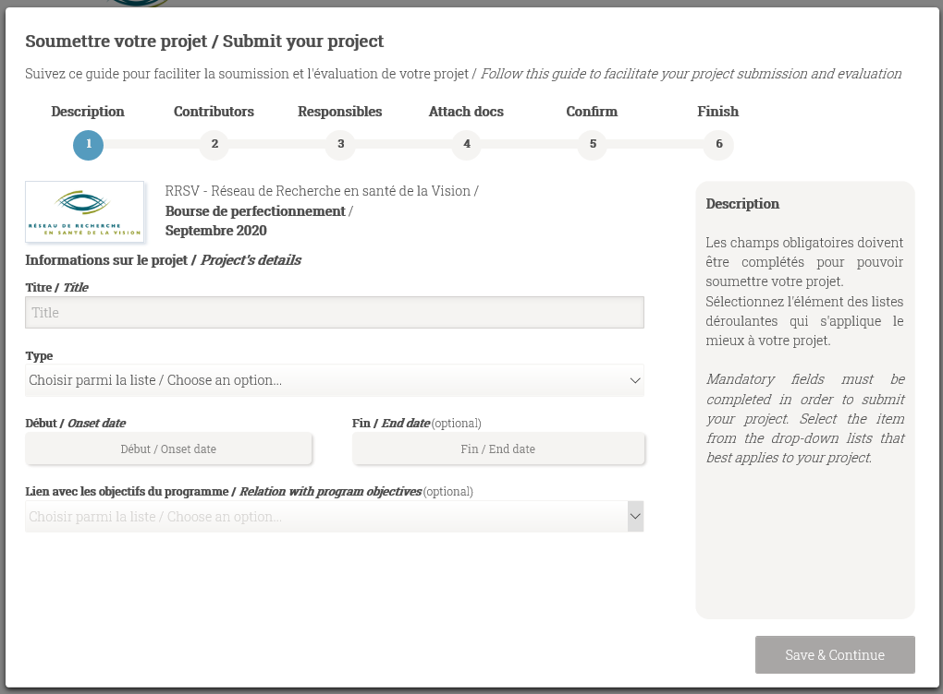

Step 1 - Description

Informations sur le projet / Project’s details

Titre / Title: MSc / PhD / postdoctorate project’s title to which this application is related

Type: choose from the drop-down list the type of research – discovery research, translational, clinical, etc.

Début / Onset: date you started the study program to which this application is related

Fin / End date (optional): end date of this diploma if known. If the date is unknown, write nothing

Lien avec les objectifs du programme / Relation with program objectives (optional): choose form the drop-down list the type of event – “activité de diffusion scientifique” (presentation at a scientific event) or “formation de courte durée” (training)

Save & Continue

Step 2 - Contributors

Information sur la personne / Person’s information

Courriel / Email: applicant’s email address (student / post-doctoral fellow)

Prénom / First Name, Nom / Last Name: complete the fields

Rôle / Role: choose the option: « Student / Trainee »

Expérience / Experience: choose from the drop-down the degree or title that you are undertaken: Master, Doctorate, Fellow, MD Student, Other, etc.

Discipline: choose from the drop-down list the area of research by starting to write

Secteur / Sector: will be displayed automatically according to the chosen discipline, do not write anything

Affiliation principale / Principal affiliation: identify the place where you will perform your research – École d’optométrie, Research Center or Institute X, University of X, etc.

Save contributor

MANDATORY:

To add your supervisor, click on New contributor .

Complete the fields.

Rôle / Role: choose the option: « Director »

Save contributor

OPTIONAL:

If you have a co-supervisor, click again New contributor and complete the fields.

Rôle / Role: choose the option: « co-Director »

Save contributor

When you have finished adding all the contributors: | Save & Continue

Step 3 – Responsibles
Responsables du projet / Project responsibles
The project responsible is the applicant i.e. student / post-doctoral fellow. | Save & Continue

Step 4 – Attach docs
Téléverser les documents requis (si applicable) / Upload all required documents (if applicable)

Click to upload your documents one at the time and click on UPLOAD (only one combined PDF document).

When the document is attached: | Save & Continue

Step 5 – Confirm
Résumé de l’information à soumettre / Resume of the information to submit

Save & Continue
Step 6 – Finish
Soumission préliminaire / Pre-submission
The applicant is the person in charge of the final submission. | Envoyer courriel / Send email

End of the electronic form

You will receive an email for the final submission.

You will have the opportunity to modify ( Modifier / Modify ) and review your application (Visualiser le rapport / See report ) before submitting.

Following clicking on SOUMETTRE / SUBMIT , a submission confirmation window will appear.

Confirm the final submission.

˃ Your application has now been submitted to the VHRN. ˂

Applicant (First name LAST NAME): ___________________________________

SECTION 1 : ADDITIONAL QUESTIONS

- Indicate your study program: ___________________________________________________

- Could this project have an impact on the understanding and / or treatment of AMD? ☐ yes ☐ no

- Does this project result from the use of a VHRN resource? ☐ yes ☐ no
If yes, specify.
☐ Common Infrastructures (specify which one(s): ______________________________________)
☐ National and International Networking Program
☐ Other (please, specify: ___________________________________________)

Type of event:

☐ Conference ☐ Meeting ☐ Symposium ☐ Workshop ☐ Other ______________
Type of presentation: ☐ Oral presentation ☐ Poster presentation

OR

☐ Short-term training

- Nature of the event: ☐ National ☐ International

- Name of the event:

Date of the event (and duration):

Web site:

Location (University/Research Institute/Congress Center, city, country):

SECTION 2 : JUSTIFICATION (300 words maximum)

Presentation at a scientific event
- Describe your current and past training
- Describe your contribution to the project
- Discuss impact of your participation to the event on your training and its relevance to the mandate of the VHRN (development of collaborations, acquisition of new expertise, etc.)

Short-term training
Describe the activities to be carried out, your role, and how it will impact your training and future research capacity in your current training environment.

Applicant (First name LAST NAME): ___________________________________

SECTION 3 : PRESENTATION DETAILS - Presentation at a scientific event only

Title:

Authors:

Submitted abstract:

Applicant (First name LAST NAME): ___________________________________

SECTION 4 : TRAINING DETAILS - SHORT-TERM TRAINING ONLY

Contact info of the host researcher

LAST NAME, First name:

Email:

Affiliation:

Address:

List of all the persons related to the project and function
Names | Function (MSc/PhD student, Post-doctoral fellow, director, collaborator, host researcher, assistant, technician, etc.)

Description of the host training environment (maximum 100 words)

Applicant (First name LAST NAME): ___________________________________

SECTION 5 : COST ESTIMATION

Complete the table.

Expenses details | Amount  ($ CAN)
Total*

* Even if your total exceeds $ 1,500, the network will issue the recipient a check for up to $ 1,500.

NB: Original invoices and boarding pass are required for refund.

