RENEWAL APPLICATION FORM FOR THE SUPPORT OF A

COMMON INFRASTRUCTURE

VISION HEALTH RESEARCH NETWORK

2020-2021 Competition

INSTRUCTIONS

Deadline for submission: October 15 2020* November 2nd 2020
*Should this date falls on a Friday or Saturday, the candidates will have until Sunday night to send their application.
Goal
The goal of the Common Infrastructures program is to provide resources and tools for researchers of the Vision Health Research Network (VHRN) that they could not otherwise afford, in an effort to promote vision research in Quebec.

Impact of the program
The VHRN common infrastructures have become essential to several laboratories of the Network. Their impact is undeniable in terms of number and quality of scientific articles published in peer-reviewed journals, presentations at provincial, national and international conferences, and research funds. Research based on the use of these infrastructures has, on several occasions, strategically influence knowledge transfer and implementation of new practices. For instance, the VHRN Database Visual Impairment & Rehabilitation has notably influenced policy for low vision care in Quebec. The Common Infrastructures program is by far considered as being the most useful and most efficient of the VHRN programs and we intend for it to remain so.

Eligible infrastructures
The types of infrastructures currently allowed are listed below. For funding of other types of infrastructure, please consult with the executive committee of the Network.
- Cell, tissue or other biological material database
- Genetic databases
- Clinical databases
- Registries
- Common technical platforms
- Tools to measure visual function (development and validation of questionnaires, etc.)

Equipment, even for multiple users, is not typically the type of infrastructure supported by the Network. An exception could be made for the maintenance and/or development of an apparatus to be used by a very large number of researchers, members of the Network. This program does not covered user fees (usually covered by operating grants).

The Network will not fund an infrastructure that will benefit only a small group of researchers or a single team. The common infrastructure must benefit several researchers from several teams, and ideally from several institutions to be supported by the Network. The common infrastructure must be readily available to all Network members upon request.

Ethics
In the case of a clinical registry, clinical database, genetic material, or tissue bank, the endorsement by the Ethics committee of the institution responsible for the bank or the registry is a mandatory prerequisite to any access and/or use of this data bank or registry.

Evaluation Criteria
Applications for common infrastructures maintenance funding will be evaluated according to the same performance criteria as those established by the FRQS for the evaluation of its Thematic Networks. These same criteria are also specified at the top of each section of this form, as well as in the VHRN Scientific Report form.
Amount and duration of grants
The financial support of a common infrastructure is granted for one year. The maximum budget for an infrastructure is $ 30,000. Occasionally, on demonstration of a particularly high performance, this amount may rise. In any cases, the amount will depend on the availability of funds. Funding is renewable upon completion of a renewal application, which include a scientific report.

Documents to submit
The application must be submitted as single PDF document including, in the following order:
- The ‘Renewal for the support of a Common Infrastructure’’ form duly completed;
- Complete the web forms for the registration of new projects since 1 December 2018 (see section " DEPOT DES PROJETS" of this present form);
- Letters of support when applicable (certificate of partnership);
- Common CV of the researcher who manages the infrastructure (FRQS, CIHR or NSERC format) (2 versions);
  - PDF version
  - XML version
- Partial financial report (only expenses made after March 31st 2020 if there is an over of more than 25% of the total annual funds in the financial report initially submitted to the FRQS).

Commitment

It is mandatory to mention support from the Vision Health Research Network in any publication or presentation resulting from the use of an infrastructure funded by the Network. The manager of an infrastructure funded by the Network (i.e. who endorses the application) is responsible to ensure compliance of this rule by each of the users of that infrastructure. Acknowledging the VHRN is free and it is a useful tool to demonstrate the impact of the VHRN.

Research resulting from the use of this infrastructure must be presented at the Annual Meeting.

Scientific Report
For all funded common infrastructures, a scientific report including scientific impacts and leverage effects must be completed at the end of the grant. In the case of a renewal application, this report will be included in the Renewal application form. The document "Scientific Report" is to be completed only if a request for renewal is not requested (Scientific Report available on the VHRN website). These reports will be used integrally in the Network's Annual Report and Network renewal application.

Financial report
For any VHRN funded project, a financial report must be submitted to the FRQS (portals - FRQnet) at the end of the financial year (Mach 31st) following the grant year. The directives concerning the transmission of this report will be communicated to the infrastructure manager. As mentioned by the FRQS in their Network Management Guide, at the end of the grant period, the unexpended amounts will have to be returned.

Number of grants: dependent on the availability of funds (total of nine (9) infrastructures).

Please submit an electronic version of your application to: reseau.vision@ircm.qc.ca

For additional information, please contact:

Vision Health Research Network
514-987-5636
reseau.vision@ircm.qc.ca
visionnetwork.ca

RENEWAL APPLICATION FOR THE SUPPORT OF A
Common Infrastructure

Vision Health Research Network

Grant Year 2020-2021

Form

Deadline for submission: October 15 2020* November 2nd 2020
*Should this date falls on a Friday or Saturday, the candidates will have until Sunday night to send their application.

PERIOD COVERED BY THE RENEWAL
December 1st 2018 – September 30 2020

TITLE OF THE COMMON INFRASTRUCTURE (English and French):

SHORT TITLE OF THE COMMON INFRASTRUCTURE (maximum 35 characters, English and French)

Manager of the infrastructure (must be a faculty member of a recognized Quebec university or a permanent member of a clinical ophthalmology unit of a university hospital.)

LAST NAME, First name and titles:

Main affiliation:

Address:

Email:

Phone number:

Statement and signature of the person responsible for the Infrastructure:

As the manager of the Infrastructure mentioned above, I declare that, in the case of a clinical, genetic or human tissue register or database, no data will be transferred or used without the prior consent of the ethics committee of the institution of the researcher who will use them;

As the manager in charge of the Infrastructure mentioned above, I declare that contributors and users have been advised of their inclusion in this report.

_____________________________________________________________________________________________

Name Signature date

ADMINISTRATIVE INFORMATION
Complete information of the Finance Director or the representative who will manage the grant

LAST NAME, first name:

Email:

Phone number:

Institution’s name (to which the cheque will be payable to)

Complete address where the cheque must be sent:
(office number, civic number, street name, city, postal code)

Fund number (if available):

CONTACT INFORMATION
Contact information to whom requests to use the infrastructure data should be directed.

LAST NAME, first name:
Email:
Phone number:

Institution’s name:

Suggestion of potential evaluators (5 names)
The evaluators must not have published with you with the researcher outside Quebec during the last five years.
Include: LAST NAME, first name, titles, affiliation, email, phone, expertise.

DESCRIPTION OF THE INFRASTRUCTURE (maximum 1 page)
- Describe the infrastructure: (1) nature and mission of the infrastructure, (2) type of data or biological material, type of studied parameters, number of patients, etc.
- Describe (3) how this infrastructure is the managed and describe its (4) accessibility to the members of the Network.
- Describe the (5) the management of the ethic aspect.

« DEPOT DES PROJETS »

Wishing to facilitate the monitoring of activities and their impact while insuring to meet the requirements of to FRQS requests in terms of performance assessment, please register all new projects since your last renewal according to the following procedure:

- For each new project, use the web form to register the project (the web link for the form has been sent to the infrastructure manager);
- The form can be completed by anyone who has the link (eg the manager can send the link by email to the researcher responsible for the project, see Appendix 1);
- When the form is completed, the information on the project is sent directly to the VHRN (therefore this information will no longer be requested in the renewal reports) and an email notification is sent to the infrastructure manager (see Appendix 1 for a visual of the procedure).

« RETOMBÉES DES PROJETS »
Since we are still in a transition period for performance assessment, we will proceed to record the impact of projects in a conventional way, i.e. by completing an Excel file. Starting next year, we will use dynamic custom forms to be completed by each project manager / responsible (see previous section " Depot des projets ").

GENERAL INSTRUCTIONS

- Each infrastructure manager will receive a customized Excel file including the list of all projects that were registered during the last renewal in their platform (" Liste des projets " tab).

- For each project, enter the impacts (“ Retombées ” tab). Each row corresponds to a type of impact.
NOTE: add the number of rows needed for each project.

- The types of impact are as follows:
- Journal article (committee by pairs)
- Book chapter
- Oral communication - provincial conference
- Oral communication - national conference
- Oral communication - international conference
- Poster communication - provincial conference
- Poster communication - national conference
- Poster communication - international conference
- Leverage effect

- When you select the type of impact, the information to provide will be revealed in the “ Informations à fournir ” column. You must complete the description of each impact. For your information, the instructions are as follows:
- Any type of Publications (article and book chapter): Pubmed format or equivalent. Also indicate if the article has been published, submitted or accepted for publication.
- Any type of Communications: Title, authors, name of the conference, place, year
- Leverage effect: Describe the leverage effects (subsidies, public or private investments, partnership with the biopharmaceutical industry or others) resulting from the use of this infrastructure. Specify the title of the grant, the authors, the granting body, the start and end dates and the amounts per year. Briefly explain how the VHRN facilitated the grant. If this is an "in kind" partnership, describe it and estimate the amount.

- Please indicate if the VHRN was acknowledged for this impact
* Reminder: It is essential that the researchers thank the VHRN, and / or the Antoine-Turmel Foundation (FAT) when applicable, in each of the publications and presentations to which the funding of the VHRN or the FAT contributed (directly or indirectly). If this has not been done, the FRQS will not consider these articles and summaries in the Network's evaluation, which will have the effect of reducing the pass mark and possibly the amount of funds allocated.

- Put in bold the names of the researchers of the Network.

SCIENTIFIC RESULTS (maximum 2 pages)
Describe the scientific discoveries ensued from the use of this common infrastructure since December 1st 2018. Please make the content of your text accessible to a researcher who is not in your field.

PERFORMANCE (maximum 4 pages, excluding this page)

Describe the relevance, strategic nature and impact of this infrastructure since December 1st 2018.

Do not repeat the information in the scientific results section.
Include only information relevant to the infrastructure.

Renewal applications will be assessed following the FRQS performance criteria established for the evaluation of their Thematic Networks, as listed below.

Please answer to all following items when applicable).

- Development of new strategic and structuring initiatives
- National and international visibility
- Biotechnology development
- Added value for VHRN members and the scientific community
- Development of cross-sector projects and poles of excellence
- Training of the next generation
- Promotion of clinical research
- Added value for target community (new treatments, new personalized health care implementation of new health practices or policies).
- Knowledge transfer, valorization and public communications activities
- Free access to the results
- Highlight success stories

SCIENTIFIC PROGRAM AND BUDGET (maximum 2 pages)

- Describe the strategic and structuring nature of the infrastructure for the upcoming year
- Detail the amount requested from the RRSV for the next year

Appendix 1

Illustration of the different steps involved in registering new projects

Step 1. Transmission of the link to the person who will be in charge of completing the web form (project manager, student, infrastructure manager, etc.)

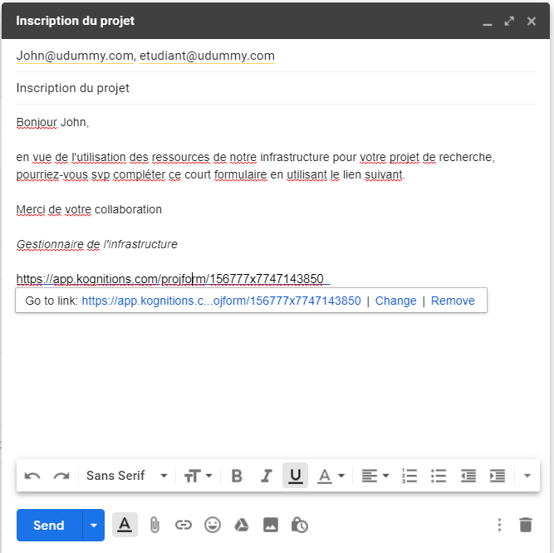

Step 2 Completion of the different sections of the form
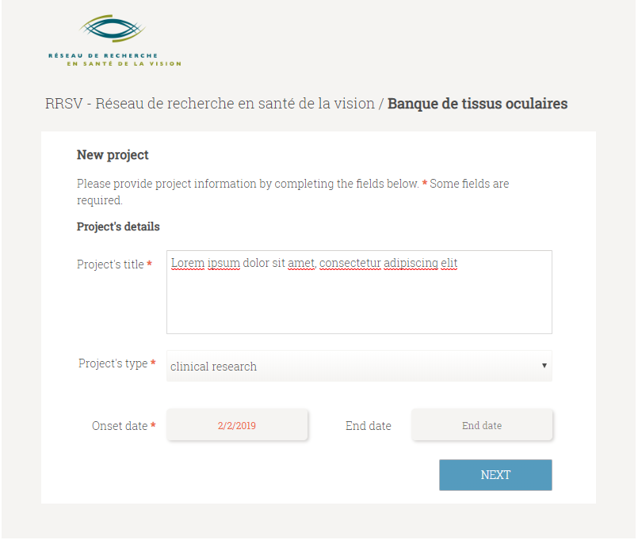

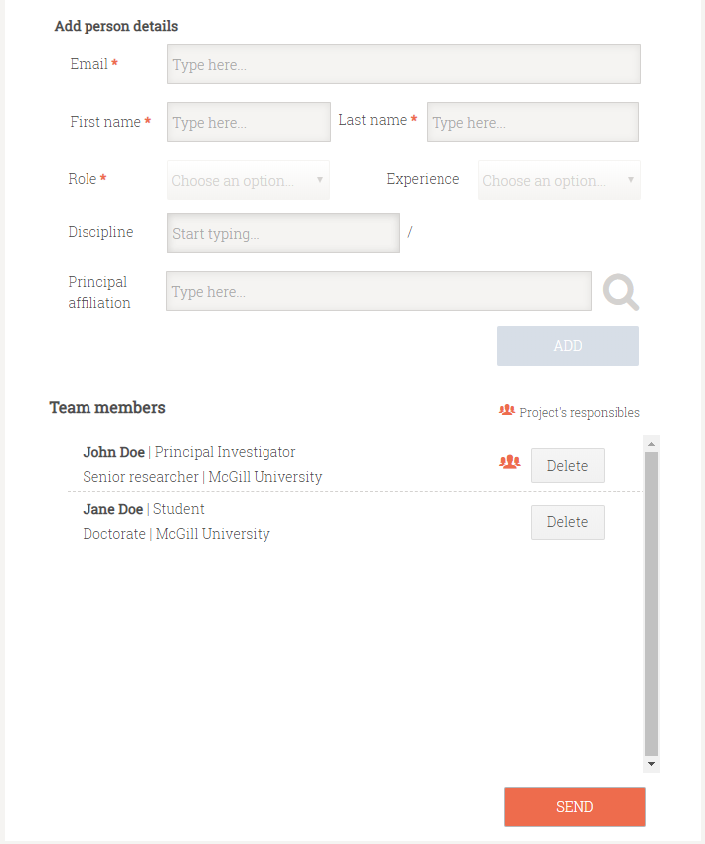

Step 3. Receipt of an email notification to the Infrastructure Manager of the registration of a new project

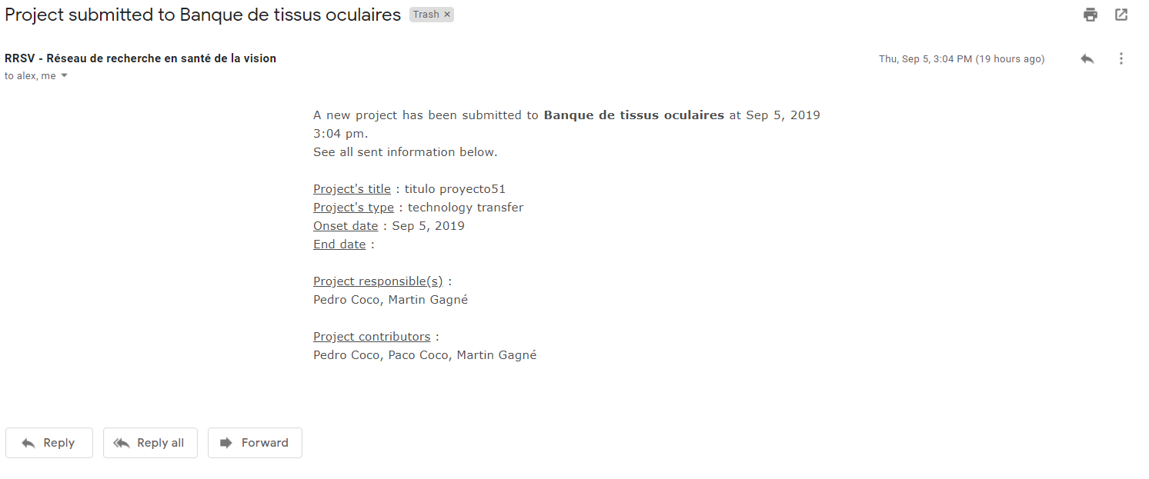

Appendix 2
2020-2021
List of VHRN COMMON INFRASTRUCTURES
ELIGIBLE FOR RENEWAL

01_Drusen/DMLA DATABASE (A. Johnson)
02_scGenAP (J.S. Joyal)
03_CORNEA BANK (j. Meunier)
04_OCULAR TISSUES BANK (S. Proulx)
05_UVEAL MELANOMA DATABASE (S. Landreville)
06_ORVIS (W. Wittich)

