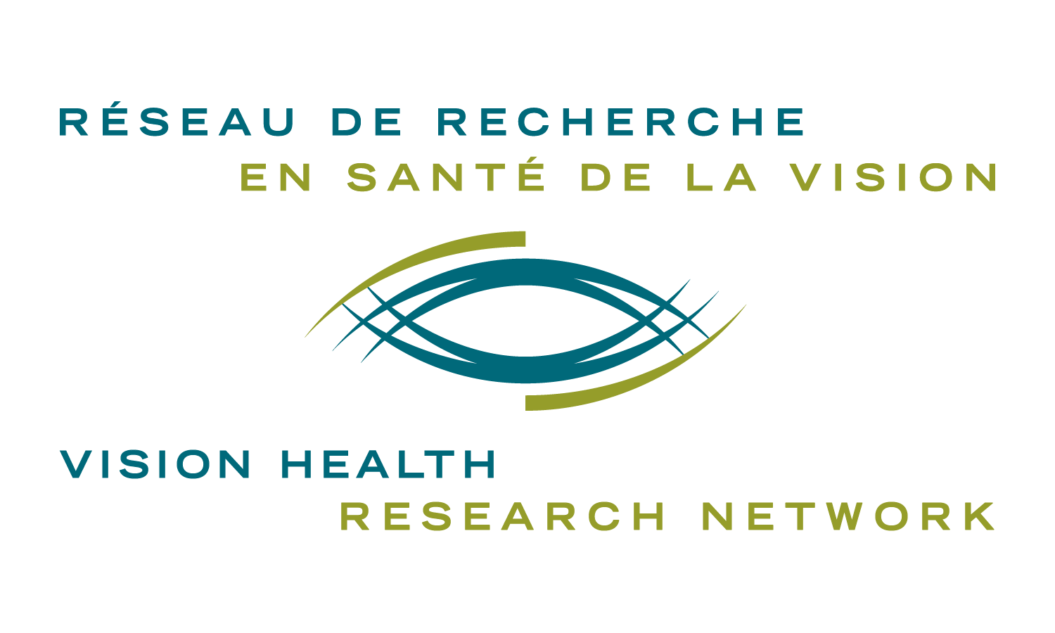

FUNDING FOR THE ORGANIZATION OF A SCIENTIFIC EVENT BY A MEMBER OF THE VHRN

VISION HEALTH RESEARCH NETWORK

2021 – 2022 Competition

INSTRUCTION

Deadlines: September 30, 2021*
February 28, 2022*

*Should these dates fall on a Friday or Saturday, the candidate will have until Sunday night to send the application.

Goal
The objective of this initiative is to provide financial support to members of the Vision Health Research Network (VHRN) who are organizing a dissemination or knowledge transfer event (conference, symposium, provincial, national or international scientific conference, café scientifique) in the field of vision research.

Eligibility
To qualify for this type of funding:
- The candidate must be an active member of the VHRN;
- He must be the organizer or be part of the organizing committee of the scientific event;
- The event must have a direct link to vision research.

The request must include:
- The form below, duly completed.
- Proof of participation in the event as organizer

Evaluation criteria
Priority will be given to applications that meet the objectives of the Network:
  - interests and repercussions for the network;
  - international visibility of the network;
  - promotion of infrastructures (valorisation, improvement, advertising);
  - promotion of tissue banks;
  - potential for attracting new collaborators.
Funding will be awarded to the application with the highest impact (i.e. most deserving).

Amount and number of funding
Funding of up to $ 1,500 will be awarded. The amount of funding depends on the availability of funds. Only one funding per financial year per axis may be allocated for this program. Prizes or awards are not eligible expenses.

Commitment
Any recipient of funding for scientific event must:
  - include the RRSV logo in the program;
  - recognize the support of the VHRN wherever indicated, using one of the following labels, depending on the language of publication and the subject being addressed:
    - " The Vision Health Research Network " or " Le Réseau de recherche en santé de la visio n"
    - or if it is a project related to AMD: " The Antoine Turmel Foundation and the Vision Health Research Network " or " The Antoine Turmel Foundation and Le Réseau de recherche en santé de la vision"
  - promote the Network during the event, to increase its visibility, to stimulate the interest of potential new members and foster research collaborations;
  - respond to follow-up requests from the VHRN for evaluation of its funding programs.

Please submit your application to: reseau.vision@ircm.qc.ca

FUNDING FOR THE ORGANIZATION OF A SCIENTIFIC EVENT
BY A MEMBER OF THE VHRN

2021-2022 Competition

FORM

☐ September 30* ☐ February 28*

*Should these dates fall on a Friday or Saturday, the candidate will have until Sunday night to send the application.

Please complete the following sections and add the number of lines needed.

Title (Mr/Mrs):

Last name, First name:

Email:

Address:

Phone number:

Axis:

University, Faculty and Department:

Date of the event:

Amount requested: ☐ $ 500 ☐ $ 750 ☐ $ 1000 ☐ $ 1500 Other, specify:____________

Name of the event:

Event type: ☐ Conference ☐ Congress ☐ Café scientifique ☐ Symposium ☐ Other:__________

Web site:

Location:

Targeted participants:
Targeted participation: ☐ Local ☐ Regional / Provincial ☐ National ☐ International

Description of the event (between 250 and 350 words):

Use of funds (justify the amount, budget):

Role of the candidate in the context of the event (Include any supporting documentation):

Is this event at least partly related to AMD? ☐ Yes ☐ No

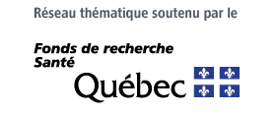
For further information and / or to confirm your eligibility:
Vision Health Research Network
Teleworking: 438-825-1425 / IRCM: 514-987-5636
reseau.vision@ircm.qc.ca
reseauvision.ca

