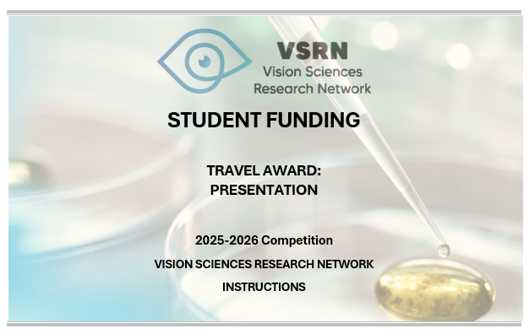

EDITION | Deadlines application* | For travel which starts between:
Spring/Summer | January 13 2025 | March 1st to August 31st 2025
Fall /Winter | July 1st 2025 | September 1st to February 28 2026

*Should these dates fall on a Friday, Saturday or Sunday, the candidates will have until Monday night to send their application.

Objectives

The purpose of this initiative is to provide financial support to undergraduate (Cegep) and graduate student (all cycles) and postdoctoral fellows of the Vision Sciences Research Network (VSRN) for their active participation in a scientific event. Those selected must give a PRESENTATION (oral or poster) at a national or international scientific event (conference, symposium, workshop, congress), either in-person or virtual.

The specific objectives of the program are to:
- Promote networking and collaborations;
- Facilitate student mobility and participation in national and international scientific events;
- Reward excellence in vision health research by VSRN trainees;
- Gain recognition for the excellence of their work within the national and international scientific community;
- Help trainees acquire unique expertise essential to increase research capacity

Eligibility

The eligibility criteria for this program are:
- Relevance of the project to the VSRN's mission and areas of vision science research. Applications that do not correspond to the RRSV's mandate will not be evaluated;
- This competition is open to all student members of the Vision Network.
- You must be a student (college, all university levels), postdoctoral fellow or resident in a Quebec teaching institution, university hospital, research centre/institute or other healthcare organization under the supervision of a Vision Network member researcher;
- The contest will be held twice (2) a year, and you must apply by the deadline that corresponds to the period when your event will take place;
- Only one (1) application per candidate will be accepted for each competition.

Amount and number of awards

- Each grant will consider the budget submitted (see section 3).
- Maximal funding t is $ 2,500* per student (in-person) and $ 200 for a virtual meeting.
- The number of awards depends on the availability of funds for this program.
- Only one (1) award per student per financial year (April 1st to March 31st) may be awarded for this program. Please contact reseau.vision@ircm.qc.ca if you have any questions about your eligibility.
*July contest only

Eligible expenses

Congress registration fees, association membership fees, transportation costs (economy class), permit and visa fees, medical insurance costs, accommodation costs, meal costs ($50/day - excluding alcohol) are all eligible expenses.

Evaluation criteria

The evaluation committee will assess the application based on the excellence of research, being attended, and the potential of the student’s participation to help increase capacity in vision in Quebec. Each application will be evaluated and ranked using the following material:

Scientific quality of the submitted abstract

Quality of the letter of justification

Fair and reasonable budget

Letter of support from the supervisor

Commitment

Any recipient of VSRN grants agrees to:
- Acknowledge the support of the VSRN wherever indicated, using one of the following wordings, depending on the language of publication and the subject matter:
« Le Réseau de recherche en sciences de la vision » / « The Vision Sciences Research Network »
- Respond to the requests for follow-up sent by the VSRN in order to evaluate the efficiency of this program
- Present the results of the research project at the VSRN Annual meeting

How to apply

The applicant must complete the electronic form (sections 1-2-3) available on the “Travel award: Presentation” program homepage and attach the appropriate documents (one combined PDF Document):

Following this order:
- Confirmation of registration * and submission* (oral/poster)
- Cost estimate (section 4)
- Canadian Common CV in FRQS format for the candidate, including detailed contributions
- Signed support letter from the research supervisor highlighting the relevance of the travel (participation and contribution of their student to the event) and the impact on the student's training and the development of research capacity in their laboratory

*: These documents can be provided later (by email to the RRSV) if they are not available at the time of application.

IMPORTANT: The scholarship payment will be made after the event, once all supporting documents mentioned above, as well as receipts (official receipts, boarding passes, etc.), have been received by the VSRN.

Incomplete and/or non-compliant applications will be rejected.


For additional information, please contact:
Vision Sciences Research Network (visionnetwork.ca)
reseau.vision@ircm.qc.ca



SECTION 1 - IDENTIFICATION

*Applicant: First Name Last Name Email

*Degree: 1st,2nd or 3rd cycle student, MD student, Postdoctoral Fellow, resident/fellow

*Type of research: Discovery, clinical, translational (preclinical), epidemiology, knowledge transfer, technological transfer, social sciences, politics and public health

*Study Program: (to complete)

*Affiliation: University, Research Center, institute, etc.

*Supervisor: First Name Last Name Email

Co-Supervisor (if applicable): First Name Last Name Email

*Axis: Vision Neurosciences, Emerging Technologies, Rehabilitation and Social Issues of Visual Disorders, Biology and Pathology of vision

* Involved sectors: Health, Natural Sciences and Engineering, Social Sciences and Humanities, Arts and Letters

*Does this project result from the use of a VSRN resource? No / Yes
(Network Programs: Common Infrastructures, National and International Networking or other VSRN Student fundings)

Is this project part of an application for funding other than the VSRN? No / Yes
(If yes, please specify: Application deadline: ___Funding agency: __, Name of funding program:____)

*Type of activity: in-person, virtual

*Type of presentation: Oral presentation, Poster presentation

*Scope of the event: Provincial, national or international

*Name of the event: (to complete)

*Starting date (duration): YYYY-MM-DD (x day(s))

*Place: University / Institute / Congress Center, city, province, country

Web site (if known): (to complete)

*Mandatory

SECTION 2 : DETAILS ON THE PRESENTATION

Title:

Authors:

Summary of the submitted communication:

SECTION 3 : JUSTIFICATION (maximum 400 words)

a) Describe your current and past training.

b) Describe your contribution to the project.

c) Describe the impact of your participation in this event on your training and its relevance to the mandate of the RRSV (development of collaborations and acquisition of new expertise) and the intersectoral nature of the event.

SUPPORTING DOCUMENTS

Attach all sections and additional documents to the electronic form in a single PDF (see previous page)

Submit

You will receive an email confirming your submission.

Applicant (First name LAST NAME): ___________________________________

SECTION 4 : COST ESTIMATION

Complete the table.

Expenses details | Amount  ($ CAN)
Total*

* Even if your total exceeds $ 1,500 (in-person event) or $ 200 (virtual meeting), the network will issue the recipient a check for up to the maximum

NB: Original invoices and boarding pass are required for refund.

